Activity 1:
This program illustrates how data in the variables are manipulated. Translate the instruction as given below
Solution:
public class Activity1{
public static void main(String [] args){
int num1;
int num2;
double sale;
char first;
num1 = 4;
System.out.println("num1 = " + num1);
num2 = 4 * 5 - 11;
System.out.println("num2 = " + num2);
sale = 0.02 * 1000;
System.out.println("sale = " + sale);
first = 'D';
System.out.println("first = " + first);
} }
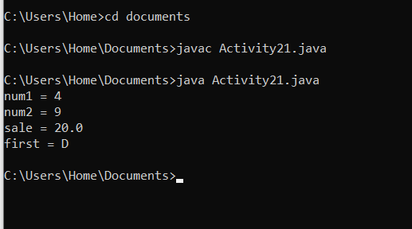
Activity 2: This program illustrates how input statements work.
Solution:
import java.util.Scanner;
public class Activity22{
public static void main(String [] args){
Scanner console = new Scanner(System.in);
int feet;
int inches;
System.out.print("Enter two integers separated by spaces.");
feet = console.nextInt();
inches = console.nextInt();
System.out.print("feet = " + feet);
System.out.print(" inches = " + inches);
} }
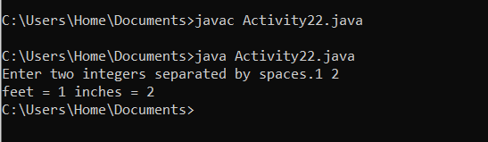

Activity 3:
This program illustrates how to read strings and numeric data
Solution:
import java.util.*;
public class Activity23{
static Scanner console = new Scanner(System.in);
public static void main(String [] args){
String firstName;
String lastName;
int age;
double weight;
System.out.println("Enter first name, last name, " + "age, and weight separated " + "by spaces.");
firstName = console.next();
lastName = console.next();
age = console.nextInt();
weight = console.nextDouble();
System.out.print("Name: " + firstName+ " " + lastName);
System.out.print(" Age: " + age);
System.out.print(" Weight: " + weight);
} }
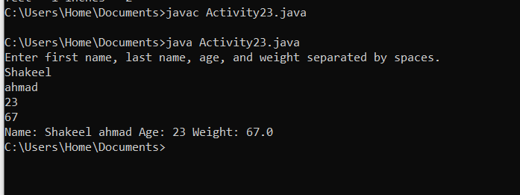
Activity 4:
This program demonstrates the close relationship between characters and integers
Solution:
public class Activity24{
public static void main(String[] args){
char letter;
letter = 65;
System.out.println(letter);
letter = 66;
System.out.println(letter);
} }
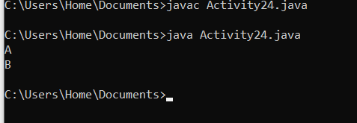
Activity 5:
This program illustrate the concept of constants used in java
Solution
import java.util.Scanner;
public class ComputeAreaWithConstant {
public static void main(String[] args) {
final double PI = 3.14159; // Declare a constant
Scanner input = new Scanner(System.in);
System.out.print("Enter a number for radius: ");
double radius = input.nextDouble();
double area = radius * radius * PI;
System.out.println("The area for the circle of radius " +
radius + " is " + area);
}
}

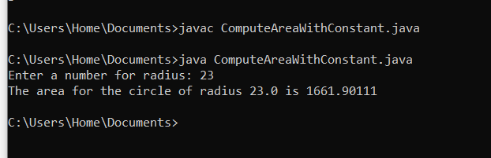
Lab Task 1
Consider the following program segment //import classes public class Activity1 { public static void main(String [] args) { //variable declaration //executable statements } } a. Write Java statements that declare the following variables: num1 , num2 , and num3 , and average of type int . b. Write Java statements that store 125 into num1 , 28 into num2 , and -25 into num3 . c. Write a Java statement that stores the average of num1 , num2 , and num3 into average. d. Write Java statements that output the values of num1 , num2 , num3 , and average . e. Compile and run your program.
Solution
//importjava.util.*;
public class Grades{
public static void main(String [] args){
int num1;
int num2;
int num3;
int average;
num1 = 125;
num2 = 28;
num3 = -25;
average = (num1+num2+num3)/3;
System.out.println("average " + average);
}
}
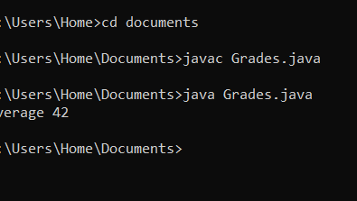

Lab task 2
Consider the following Java program in which the statements are in the incorrect order. Rearrange and format the statements so that it prompts the user to input the length and width of a rectangle and output the area and perimeter of the rectangle.
import java.util.Scanner;
public class Grades2{
public static void main(String[] args){
int length;
int width;
int area;
int perimeter;
Scanner console = new Scanner(System.in);
System.out.println("Enter the length: ");
length = console.nextInt();
System.out.println();
System.out.print("Enter the width: ");
width = console.nextInt();
System.out.println();
area = length * width;
perimeter = 2 * (length + width);
System.out.println("Area = " + area);
System.out.println("Perimeter =" + perimeter);
console.close();

}}
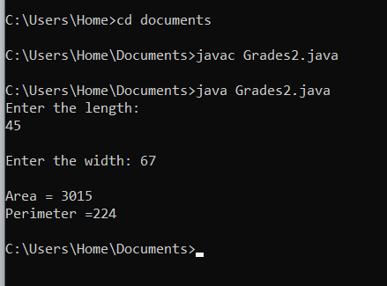

Lab Task 3
num1 is 8 and num2 is 5 , then the output is: The value of num1 = 8 and the value of num2 = 5. g) Write a Java statement that multiplies that value of num1 by 2 , adds the value of num2 to it, and then stores the result in newNum . Then write a Java statement that outputs the value of newNum h) Write a Java statement that updates the valu Consider the following program segment: //import classes public class LabTask3{ public static void main(String [] args){ //variable declaration //executable statements } } a) Write a Java statement that imports the class Scanner. b) Write a Java statement that declares console to be a Scanner object for inputting data from the standard input device. c) Write Java statements that declare and initialize the following namedconstants: SECRET of type int initialized to 1 1; RATE of type double initialized to 12.50. d) Write Java statements that declare the following variables: num1 , num2 , and newNum of type int ; name of type String; hoursWorked and wages of type double. e) Write Java statements that prompt the user to input two integers and store the first number into num1 and the second number into num2. f) Write a Java statement(s) that outputs the value of num1 and num2 , indicating which is num1 and which is num2. For example, if e of newNum by adding the value of the named constant SECRET . Then, write a Java statement that outputs the value of newNum with an appropriate message. i) j) Write Java statements that prompt the user to enter a person’s last name and then store the last name into the variable name. Write Java statements that prompt the user to enter a deci mal number between 0 and 70 and then store the number entered into hoursWorked. k) Write a Java statement that multiplies that value of the named constant RATE with the value of hoursWorked and stores the result into the variable wages . l) Write Java statements that produce the following output: Name: //output the value of the variable name Pay Rate: $ //output the value of the named constant RATE Hours Worked: //output the value of the variable hoursWorked Salary: $ //output the value of the variable wages For example, if the value of name is "Rainbow" and hoursWorked is 45.50 , then the output is: Name: Rainbow Pay Rate: $12.50 Hours Worked: 45.50 Salary: $568.75 m) Write a Java program that tests each of the Java statements in parts (a)—(l). Place the statements at the appropriate place in the preceding Java program segment. Test run your program (twice) on the following input data: a. num1 = 13, num2 = 28; name = "Mustafa"; hoursWorked = 48.30 b. num1 = 32, num 2 = 15; name = "Shakeel"; hoursWorked = 58.45.
solution
import java.util.*;
public class LabTask3
{
public static void main(String[] args)
{
Scanner console = new Scanner(System.in);

final int SECRET = 11;
final double RATE = 12.50;

int num1, num2, newNum;
String name;
double hoursWorked, wages;

System.out.println("Enter the first integer: ");
num1 = console.nextInt();
System.out.println("Enter the second integer: ");
num2 = console.nextInt();
System.out.println("The value ofnum1 " + num1 + " and the value of num2 = " + num2);
newNum = num1 * 2 + num2;
System.out.println("The value of new newNum after calculation = " + newNum);
newNum = newNum + SECRET;
System.out.println("The value of newNum after updating with secret = " + newNum);
System.out.println("Enter a person's last name: ");
name = console.next();
System.out.println("Enter a decimal number between 0 and 70 for hours worked: ");
hoursWorked = console.nextDouble();
wages = RATE * hoursWorked;
System.out.println("Name: " + name);
System.out.println("Pay Rate: $" + RATE);
System.out.println("Hours Worked: " + hoursWorked);
System.out.println("Salary: $" + wages);
System.out.println("\n--- Test Run 1 ---:");
System.out.println("\n---Test Run 2 ---");

console.close();
}
}
